**California State University Sacramento**

**Electrical and Computer Science Department**

**EEE 193A/CPE 190 - Product Design Project I**

**Final Project Report**

**CNC Laser Cutter and Engraver**



**Team Member:** Ammar Ahmed/Thomas Bock/Tan Hua/ Michael Golez

**INSTRUCTOR:** Suresh Vadhva

**Abstract**

Contents

I. Design Overview 4

A. Introduction 4

B. Equipment List 4

C. Team Member Summary 5

D. Detailed Description 5

a. Mechanics 5

b. Laser System 5

c. Software 5

d. Computer Vision 5

II. Proposals 5

A. Funding Proposal 5

B. Product Proposal 5

III. Work Breakdown Structure (WBS) 5

A. Outline of WBS 5

Mechanics 5

Laser System 5

Software 6

Computer Vision 6

B. Project Timeline 6

Milestone I 6

Milestone II 6

Milestone III 6

IV. Risk Assessment 6

A. Laser 6

B. Mechanics 6

V. User Manual 6

A. Operation 6

B. Hardware Requirements 6

C. Software Requirements 7

VI. Design Documentation 7

VII. Breakdown of Hardware Subsystems 7

A. Camera 7

B. Laser Diode 7

C. Arduino 7

D. Block diagram 7

VIII. Breakdown of Software Subsystems 7

A. Object Detection Algorithm 7

B. Generating of G-Code 7

C. Laser control 7

D. Flow Chart 7

IX. Mechanical Drawings and Documentation 8

X. Test Plan for Hardware 8

XI. Test Plan for Software 8

XII. Integration Plans 8

XIII. Accomplishment 8

XIV. Conclusion 8

XV. Appendix A: References 8

XVI. Appendix B: Code 8

# Design Overview

## ****Introduction****

All around the world there are different tools that are used to create or modify an object in order for certain materials to be applicable and used by humans everywhere. Types of device that is used by industry and commercialize companies include a laser cutter/engraving machine. Some applicable uses that laser machines have displayed over the years include Architectural models, fablabs and educational settings, and displays and gadgets. By possessing a laser machine and instrumenting a localized floorplan of its construction a user, can efficiently create objects of interest that can provide necessity.

The objective of this design group is to create a low-cost laser machine that can be used for both educational and hobby purpose. In order to create the product a Project Timeline and Work Breakdown Structure was created to ensure organized methods of accomplishing each task. Once a structured schedule was set, each individual design group focused internally on one aspect of the system and will slowly integrate the whole system prior demonstration.

The machine operates through the use of a high-energy infra-red laser light beam. By implementing a focusing lens towards the laser diode, the light beam is concentrated into a single focal point. The focal point allows maximum melting and vaporization of the desired material of interest. In order to alter the position of the laser into a desired location, a computer program known as CNC drives the positon of both the x and y axes. Asides the orientation of the axes, CNC codes can adjust the intensity of the laser to enhance the engraving or cutting of the material. Finally, by using machine vision, we can determine the position of the object relatively to the workspace through the process of object orientation. This process allows finer cutting and engraving for better result. The construction and programming of the CNC Laser Machine will be conducted into four different parts: the mechanics will handle the positions of the CORE X-Y axes, the Laser Diode will generate the light beam for the cutting and engraving, the CNC software will allow for control and intensity of the overall system, and finally detection system will detect the workspace for maximum efficiency.

## ****Equipment List****

1. Mechanical Parts:
   1. Stepper Motor (2x):
   2. Belts(2x)
   3. Linear Rods(4x)
   4. Linear Bearings(6x)
   5. LED strip(1x)
   6. Aluminum Extrusions(7x)
   7. 3D Printed Parts:
      1. X-Y Carriages()
      2. Toolhead()
      3. Linear Rail Mounts()
2. Laser System:
   1. Laser Diode: 2W 445nm M140 Blue Diode in Copper Module W/Leads
   2. Laser Lenses:405-G-2 Glass Lens for Aixiz Laser Module 405nm 445nm
   3. Laser Driver:
3. 1.8 X-Drive V6 Laser Driver-M140-PLTB450-PLTB450B-NDG700-NDG7475
4. 12V TTL 200mW to 3W 445nm 450nm Laser Diode LD Power Supply Driver
5. 2.5 Amp Adjustable Safety Compliant Laser Diode Driver Kit, for UV-Blue diodes, with International Power Adapter
6. Computer Vision:
   1. Web Cam (x1): Logitech C270 720p 3-MP
7. Microcontroller:
8. Arduino Mega with a RAMPS 1.4 motor shield
9. ACE 2510S 5V Cooler Brushless DC Fan 25*10mm Mini Cooling Radiator(2x)
10. Meanwell Style Power Supply(12V 30A)
11. Arduino Shield:

## Team Member Summary

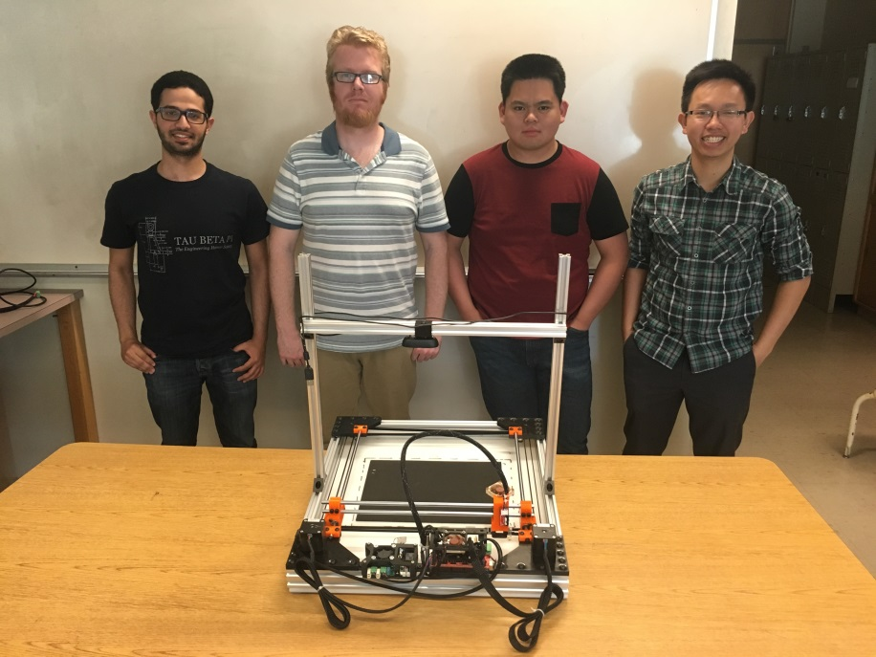

**Team Members**

From left to right: Ammar Ahmed, Thomas Bock, Michael Golez,

Tan Hua

**Ammar Ahmed -** Ammar is a senior, majoring in Electrical Engineering at Sacramento State University. His focus is in control systems with a small emphasis in Analog Design. His contribution towards the project was the development of the computer vision system. This system was implemented to get the dimension and location of the object in the working space. Currently, he is the controls team lead of the Hornet Hyperloop club. Also, he is a tutor at the Math department at CSUS.

**Thomas Bock -** Thomas is a first semester senior majoring in Electrical Engineering at Sacramento State, with a focus on control systems. His contribution to the project was the design and construction of the frame and linear motion system of the laser cutter. This system allows for accurate and reliable motion of the laser. He is currently the President of the 3D Printing Club at CSUS

**Michael Golez -** Michael is a senior engineer at California State University, Sacramento, majoring in Electrical Engineering. His primary focus is Digital/Analog Systems with a small emphasis in Control Theory. In the design of the CNC laser system, his contributions include the powering and operation of the laser diode and laser control circuitry. This involved designing and implementing a constant current source that can operate the laser safely.

**Tan Hua -** Tan is a Communication System Engineer with a minor focus on Digital Signal Processing. Over the years at Sacramento State, he spent time practicing software development. Currently he is working as an I.T. support for the state. As a result, his main focus towards the project would be the software implementation towards controlling the CNC laser system.

## Detailed Description

### Mechanics

TODO(Tom)

### Laser System

* + 1. Why Laser Diodes?
       - Low Power.
       - Easy to use
       - Compact
    2. Components
       1. 445nm 2W Blue Laser Diode
       2. 2.5 Amp Adjustable Safety Compliant Laser Diode Driver Kit
       3. 12V Power Adaptor(8 Volts at a max load of 2A)

### Software

* + 1. Objective
       1. The purpose of software in this project is to control the process of the machine including cutting and engraving.
    2. Detailed Process
       1. Computer Aided Design (CAD)
       2. Computer Aided Manufacturing (CAM)
       3. Execution

### Computer Vision

# ****Proposals****

## Funding

In reference to finding allocated funds for the production of the Laser Cutter/Engraver, each individual member proposed a draft meeting to discuss the funds needed for the production of the CNC laser system. The desired funds for the 1st semester prototype were expected to be about $1000. Because the mechanical and hardware aspect of the project covered a majority of the project the expenses was divided between both parts. Below will be a summary of the expenses purchased by each individual member in reference towards the laser cutter.

1. Mechanics

TODO(Tom)

1. Laser System

|  |  |
| --- | --- |
| Components | Cost |
| 1.8A X-Drive V6 Laser Driver | $26.00 |
| 12V Circuit Power Supply Driver Board | $13.15 |
| 12V Industrial Focusable Blue Diode Lasers | $104.50 |
| Addicore LM317T | $5.95 |
| 2 of QQ-Tech Goggles Laser Eye Protection Safety Glasses | $8.99 |
| 2W 445nm M140 Blue Diode in Copper Module W/Leads | $54.00 |
| AixiZ aluminum mount and heat sink for 12nm modules | $3.50 |
| 405-G-2 Glass Lens Aixiz Laser Module 405nm-445nm | $12.00 |
| uxcell SSR-25 DA 3-32V DC/24-380V AC Solid State Relay+heat Sink | $7.99 |
| uxcell Solid State Relay SSR-25 DD DC-DC 25A 3-32VDC/5-200VDC | $8.44 |
| Uxcell Aluminum Heat Sink for Solid State Relay SSR Heat Dissipation 10A-40A | $5.55 |
| Sum | $250.07 |

Table 1

1. Software

All components of software process are free open-sourced software including Inkscape, Repetier Firmware and Repetier Host. Therefore, it has zero cost.

1. Computer Vision

TODO(Ammar)

## Product Proposal

Before any proposals were made towards the distribution of funds on the design project, ideas were first deliberated. Each member proposed ideas that scaled to their preference concerning their core focus. The first product proposal draft included a **Bike Theft Alarm** as well as a **Parking Detector**. The reasoning behind these ideas was to explore the ideas of control and implement control theory on a system to better assist students and teachers on a campus environment. This proposal was briefly recommended towards the head instructor of project design. Proposal was rejected for lack of complexity and insufficient data.

The second proposal included the construction of autonomous machines that can assist the daily lives of humans. These product proposals included **Automated Shelving Retrieval System,** **Digital Electronic Weighing Scale, or Digital Tracking System**. By proposing these ideas, the group can re-inforce their knowledge of robotic architecture and computer vison/ architectures. Although this product proposal was favored towards the members of the design group, the proposal was considered. However, after much deliberation the product proposal was rejected. This product proposal rejection caused a setback on the project design.

On the third week, the design group proposed a final idea of constructing a laser cutter/engraver. By proposing this product, the design group can construct a machine with the sole purpose of engraving/cutting materials for both educational and hobby purpose. By constructing this machine, the design group can produce a low cost device that helps for daily artistic recreational purpose. The product idea was diverse in the multiple fields that each of our members is focusing on. The product idea heavily relied on computer vision, analog design of controlled circuits, semiconductors devices and finally, mechanical structures. After detailing the structure and application of the machine towards society the laser proposal was accepted. As a result, the laser machine should be an operational prototype by the end of the semester.

# Work Breakdown Structure (WBS)

## Outline of WBS

In order to achieve the goal of creating a working prototype by the first half of project design, project management basics are required. Below will be an illustration of the Work Breakdown Structure (WBS) for the first half of project design. The generation of the WBS, defines a hierarchical list consisting of the major elements of a project. By dividing the structure a complex project can be managed by individual members with an estimate of the time and resources. As depicted below the laser machine system was divided into four different parts: Mechanics, Laser Diode, Software, and Computer Vision.

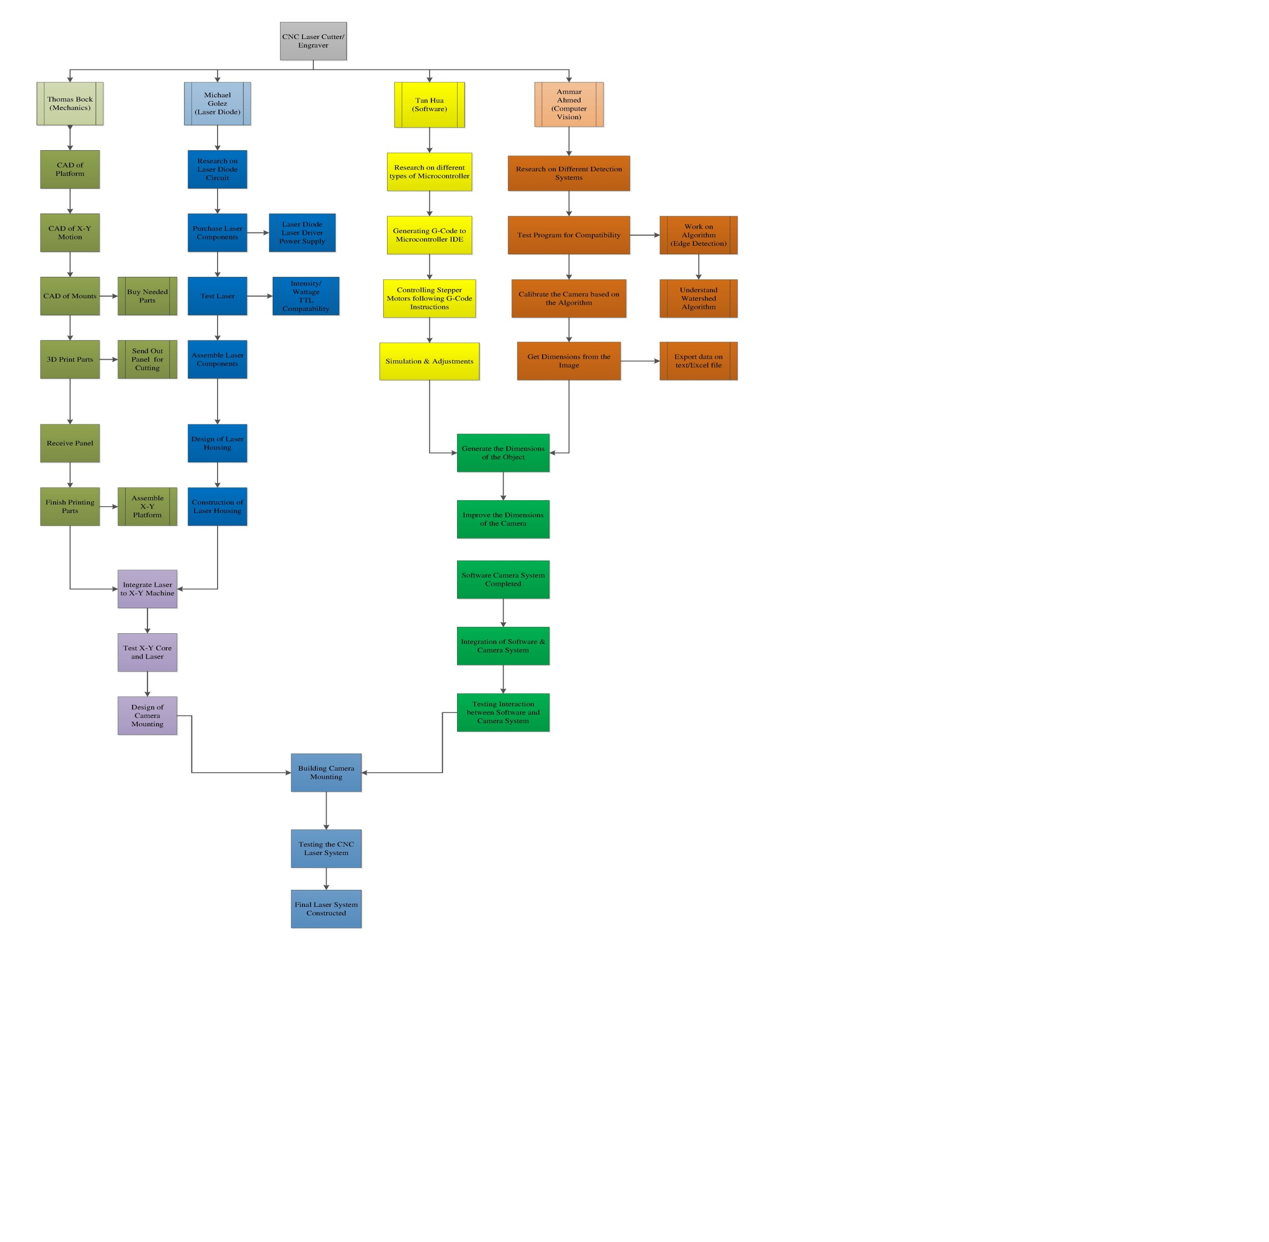

1. Mechanics:

The mechanical portion of the laser system consisted of two basic structures. The first phase focused on the primary design of the structure. The design had many drafts until a final design was constructed. Once the design was made, the next phase required integration of the system into two different phases. The first phase was mechanical/hardware integration. Once integration of the hardware with the mechanics was done, final integration with software proceeded.

1. Laser Diode:

The hardware section of the laser system consisted of two basic structures. The first phase focused on the primary limit of the current. The first design was a limiting circuit that can drive a constant current source of 1.5A towards the laser diode. Future possibilities of laser diode drive were considered. The second phase revolved around the integration of the mechanics with the laser diode. The position was vital so that when the motors rotate the laser can reach its desires value.

1. Software:
2. Computer Vision:

## Project Timeline

Asides having a Work Breakdown Structure, to organize the components of the project a Gant Chart was produced to represent the timing of the tasks required. The timing chart creates a projection of each activity and its duration an overlap and intersection of each individual part, and finally a description of each individual part. Below will be an illustration of the Project Timeline for the first half of project design. However, for detailed information, the reference displays the task assigned in the reference and projection completion date.

### Milestone I

In the first milestone, each individual was tasked with researching their individual parts such as: mechanics, laser system, software, and computer vision. Also, each member is responsible to have their individual parts to be functionally working and prepared for upcoming integration.

### Milestone II

The second milestone assigned each member to integrate their respective parts. For example, the integration of the hardware along with the mechanics, while at the same time integration of software and computer vision should be done by the second month. This projection accounts for technical issues that might arise within the integration of both systems.

### 

### Milestone III

The third milestone required that a full integration of the laser system be finished by the last month. This integration gives the design group to finalize the project in order to create a more aesthetic product that operational. By achieving this milestone the design group can showcase the final prototype during presentation, and give a demonstration of it ability and usefulness toward society itself.

# Risk Assessment (Safety)

### Laser Emission Hazard

Upon operating the 2W 445nm Blue Laser Diode the photonic beam emitted from the diode can severely injure the retina of the eye. Because the laser diode operates at a wavelength of 445nm, safety goggles are used to shield the eyes from this wavelength. Also, because the wavelength of the laser diode is dangerous to everyone who doesn’t have eye protection, the operation of the laser must be at a secluded location. This seclusion from people prevents unwanted injuries that can occur from accidental observation of the laser diode while operating.

1. **Smoke Hazard**

During Operation of laser system, the burning/engraving of materials creates a pool of smoke on the workspace. In order to account for accumulation of smoke near the workspace and on the laser diode, an external fan was used to ventilate the smoke. By using an external fan, the smoke was ventilated from the workspace preventing any buildup which can trigger a fire alarm, damage the diode, or harmful inhalation through the human body.

1. **Fire Hazard**

The last accountable factor that can affect the safety of those around the laser cutter/engraver is a fire hazard. While the device is operating thermal eunwat on the laser driver and mechanical machine can cause the system to ignite. However, in order to account for these incidents temperature control is built into the hardware devices to regulate the temperature. Also, to further prevent any casualties that can occur upon operating the laser machine, a design group member must be present upon operating the machine,

# User Manual

### Operation

* Safety considerations: Room Requirement, Objects to be cut/Engrave, Goggles

### Hardware Requirements

* Laptop: MATLAB, Inkscape
* Power Supply
* On/Off switch

### Software Requirements

* MATLAB, Inkscape with Q-Laser Plugin, Repetier Host

### Execution

TODO(Ammar, Tan) – Computer Vision and Software

# Design Documentation

# Breakdown of Hardware Subsystems

### Camera

First hardware component that begins the process is the camera. In our project, we use computer webcam because of its great compatibility with the computer. It is used to capture the object that is placed on the workspace and obtain the object dimensions.

### Laser Diode

The operational function of the laser system will be solely dependent upon the microcontroller and laser driver attached towards the laser diode. A simple laser diode will conduct a high-energy beam that can cut or engrave a material prior to user command. However, both the microcontroller and laser driver will work on conjunction with each other. The overall purpose of the laser driver is to deliver a constant current source towards the laser diode in order for the system to operate at a particular application. However, regulating the intensity and precision of the engraving/cutting required the alteration of PWM. A controller is needed to vary the output of the laser so that upon engraving/cutting a material of interest it becomes precise and accurate to the desired requirement.

In order for the laser diode to function operationally, different types of drivers were tested and applied towards the laser diode:

1. 1.8 X-Drive V6 Laser Driver:

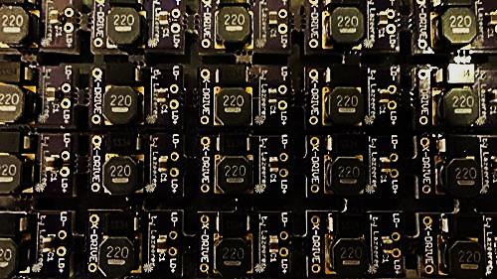

Figure 1

The 1.8X-Drive V6 Laser Driver was the first chosen laser driver to operate the laser diode. The reasoning for combining both the laser diode and X-Drive was the compatibility factor of the circuit with the 2W 445nm M140 Blue Diode. Further review listed from the vendor guaranteed that the driver has low noise capabilities along with self-bleeding caps to prevent spikes created by charged output caps. The circuit component became unnecessary because upon further inspection TTL was not compatible with the device. Another version known as the 4A Super X-Drive Laser Driver was considered, but upon inspection compatibility was not successful with the laser diode.

1. 12V TTL 200mW to 3W 445nm 450nm Laser Diode LD Power Supply Driver :

|  |  |
| --- | --- |
|  |  |

Figure 2

The 12V TTL 200mW to 3W 445nm 450nm Laser Diode (LD) Power Supply Driver replaced the X-drive because of its TTL capabilities. This circuit module provides both a current and voltage regulation towards the load, thus setting a constant source towards the laser diode. By having the user alter the output voltage and limit the current, the laser diode can operate within the region of operation. After setting the limit source, the TTL modulation can then vary the power of the laser by altering the PWM. The 12V TTL 200mW-3W Laser Diode Power Supply Driver was the main current driver used to power the laser until Compliant Laser Driver was purchased

1. 2.5 Amp Adjustable Safety Compliant Laser Diode Driver Kit, for UV-Blue diodes, with International Power Adapter:

|  |  |
| --- | --- |
|  |  |
|  |  |

Figure 3

The Compliant Laser Diode Driver replaced the previous drivers because of software compatibility and hardware features. Although the Compliant Laser Driver provides the same the capabilities as the 12V TTL Power Supply Driver, it also differed in many ways. One advantage the compliant laser driver provided was software compatibility with the Software programs such as: Matlab, InkScape, and Rasterization.

### Microcontroller – Stepper Motor Driver Shield

TODO(Tan)

### Block diagram

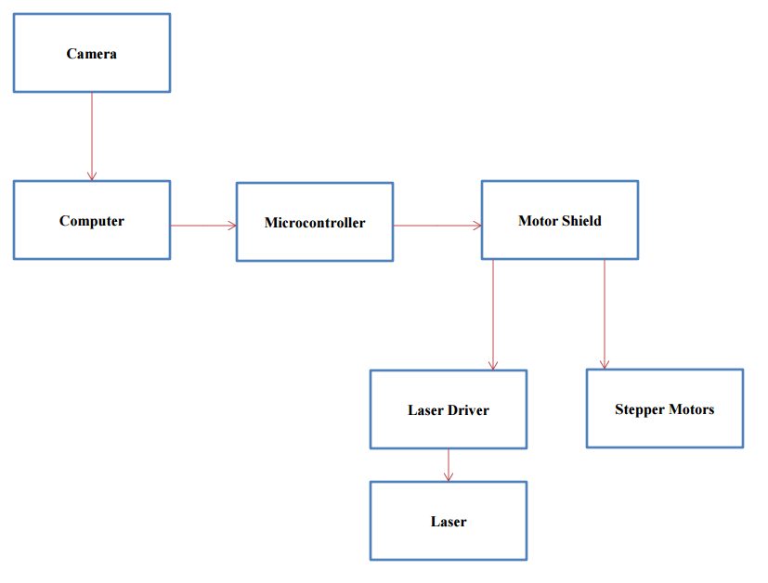

# Breakdown of Software Subsystems

TODO (TAN)

### Object Detection Algorithm

### Generating of G-Code

### Laser control

### Flow Chart

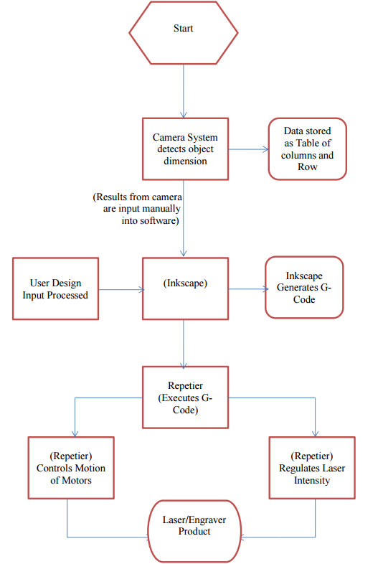

# Mechanical Drawings and Documentation

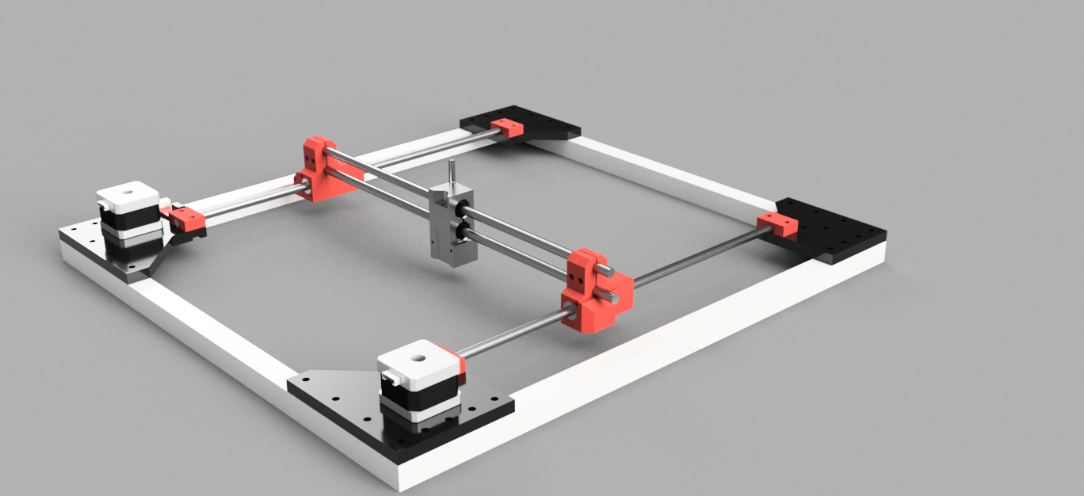

# Test Plan for Hardware

1. **Mechanics**
2. **Laser System**

The test plans for hardware consisted of two different phase in reference towards the milestone on the project timeline. Milestone I, which is established on the idea of individual components, required that the laser diode must be operational. The series of test during the first month included construction of the laser diode driver. On the first draft, laser diode driver operates, however, needed I­O, output current was not achieved. The prototype laser driver couldn’t output enough current to regulate the diode to cut/ engrave materials.

The solution found was to purchase a laser driver which has a precise point of regulating the desired current for the diode. Upon purchasing the laser diode driver with PWM, testing once again occurred. The main objective was regulated current had to be flowing through the laser diode in order for the machine to cut/engrave. Testing proved current was regulated and machine operates upon G-code command, multiple objects were cut.

The PWM of the hardware was tested to ensure that it was functioning. Upon testing it was proven that the hardware was indeed compatible with PWM. Driver was able to pulse the signal from a high-to-low over a time interval. This modification allows the machine to regulate the current to a specific intensity which is required for the engraving process.

The second phase consisted of the hardware-mechanics integration and the full system integration. During the hardware-mechanics integration the laser diode and driver were attached towards the Core X-Y platform to ensure better positon for the laser diode during operation. Once mechanical-hardware integration was finished, the next procedure was the system integration. During system integration the software must communicate with both the motors and laser diode in order for the material to be engraved or cut. During testing, there were problems encountered such as communication between the driver and software. To ensure that the machine is fully operational before demonstration continued testing/debugging was done.

Testing was completed before final week and machine was fully integrated. Demonstration was presented towards the audience to show the functioning machine and its overall purpose.

1. **Software**
2. **Computer Vision**

# Test Plan for Software

TODO(Tan) – Multiple tests with different controller

# Integration Plans

1. **Mechanics**
2. **Laser System**

The integration for the laser system was accomplished during the 9th week of design project. During this time campus was closed because of spring break. Each component of the laser system was combined together during this week. The diode was mounted to the mechanics, and the microcontroller was integrated to the laser driver to regulate the current on the laser diode. Once the full circuit was completed, testing began towards the laser diode. The whole objective was to observe whether the diode was receiving enough current to cut the desired material. The second test was to observed machine upon a PWM signal to detect whether the desired material was engraved correctly. At first glance, the test for cutting material passed, however engraving process wasn’t operational. This process of testing and debugging would continue to occur until the final system was fully operational.

1. **Software**
2. **Computer Vision**

# Accomplishment

TODO (All) – From presentation + improvement Ideas

# Conclusion

In conclusion, the design group was able to implement their knowledge of their core electrical engineering focus to create a low cost, laser system. They were able to construct a product that can be used to create/engrave a material for educational or hobby purposes.

# Appendix A: References

1. Project Timeline

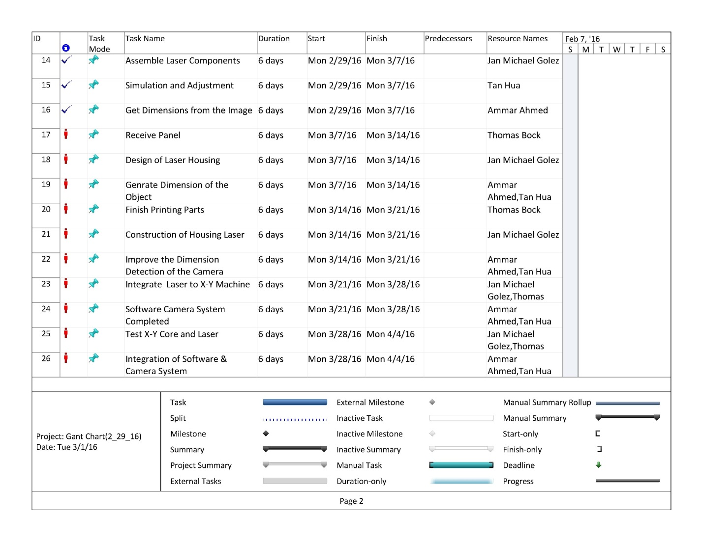

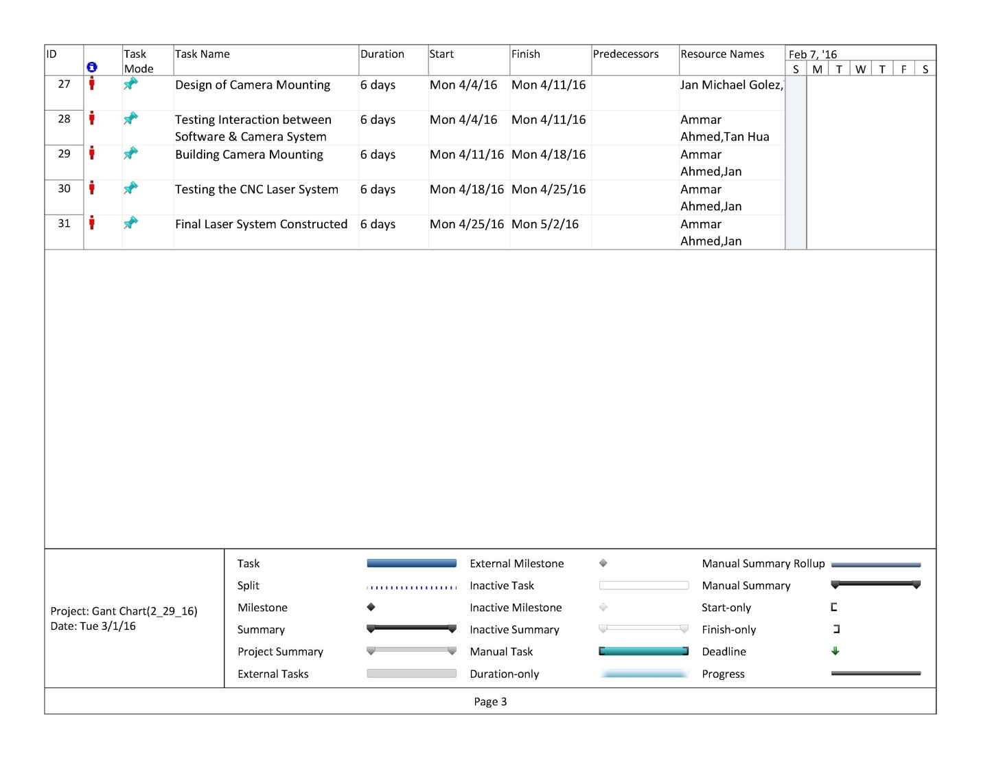

# Appendix B: Code

TODO(Tan)